



# Department of Computer Science and Engineering

**Global Campus, Jakkasandra Post, Kanakapura Taluk, Ramanagara District, Pin Code: 562 112**

**2022-2023**

**A Project Phase 1 Report on**

### “Using facial landmarks to detect drowsiness”

**Submitted in partial fulfilment for the award of the degree of**

**BACHELOR OF TECHNOLOGY IN**

**COMPUTER SCIENCE AND ENGINEERING**

**Submitted by**

**Srikar Koushik Satya Viswanadha**

**19BTRCS103**

**Vellala Harshith**

**19BTRCS083**

**Akash P**

**17BTRCS114**

**Kothapalli Bhargava Avinash**

**19BTRCS035**

**Under the guidance of**

**Dr. Rajesh A**

Professor

Department of Computer Science & Engineering

Faculty of Engineering & Technology

**JAIN Deemed to be University**



# Department of Computer Science and Engineering

**Global Campus, Jakkasandra Post, Kanakapura Taluk, Ramanagara District, Pin Code: 562 112**

# CERTIFICATE

This is to certify that the project work titled **“Using facial landmarks to detect drowsiness”** is carried out by **Srikar Koushik Satya Viswanadha (19BTRCS103), Vellala Harshith (19BTRCS083), Akash P (17BTRCS114), Kothapalli Bhargava Avinash (19BTRCS087),** bonafide students of Bachelor of Technology at the Faculty of Engineering & Technology, Jain Deemed-to-be University, Bangalore in partial fulfillment for the award of degree in Bachelor of Technology in Computer Science & Engineering, during the year **2022-2023**.

|  |  |  |
| --- | --- | --- |
| **Dr. Rajesh A** | **Dr. Mahesh T R** | **Dr. S A Hariprasad** |
| Assistant Professor  Dept. of CSE,  Faculty of Engineering & Technology,  Jain Deemed to be University  Date: 09/12/2022 | Program Head, Dept. of CSE,  Faculty of Engineering & Technology,  Jain Deemed to be University  Date: 09/12/2022 | Director,  Faculty of Engineering & Technology,  Jain Deemed to be University  Date: 09/12/2022 |

Name of the Examiner Signature of Examiner

1.

2.

# DECLARATION

We, **Srikar Koushik Satya Viswanadha (19BTRCS103), Vellala Harshith (19BTRCS083), Akash P (17BTRCS114), Kothapalli Bhargava Avinash (19BTRCS087)** are students of seventh semester B.Tech in **Computer Science & Engineering**, at Faculty of Engineering & Technology, **Jain Deemed to-be University**, hereby declare that the project titled **“Using facial landmarks to detect drowsiness”** has been carried out by us and submitted in partial fulfilment for the award of degree in **Bachelor of Technology in Computer Science & Engineering** during the academic year **2022-2023**. Further, the matter presented in the project has not been submitted previously by anybody for the award of any degree or any diploma to any other University, to the best of our knowledge and faith.

Signature

|  |  |
| --- | --- |
| Name1: Srikar Koushik Satya Viswanadha  USN: 19BTRCS103 |  |
| Name 2: Vellala Harshith  USN: 19BTRCS083 |  |
| Name 3: Akash P  USN: 17BTRCS114 |  |
| Name 4: Kothapalli Bhargava Avinash  USN: 19BTRCS087 |  |

## ACKNOWLEDGEMENT

*It is a great pleasure for us to acknowledge the assistance and support of a large number of individuals who have been responsible for the successful completion of this project work.*

*First, we take this opportunity to express our sincere gratitude to Faculty of Engineering & Technology, Jain Deemed to be University for providing us with a great opportunity to pursue our Bachelor’s Degree in this institution.*

*In particular we would like to thank* ***Dr. S A Hariprasad****, Director, Faculty of Engineering & Technology, Jain Deemed to be University for their constant encouragement.*

*we would like to thank* ***Dr. Geetha G****, Dean Academic, Faculty of Engineering & Technology, Jain Deemed to be University for their constant encouragement and support.*

*It is a matter of immense pleasure to express our sincere thanks to* ***Dr. Rajesh A, Head of the Department****,* ***Computer Science & Engineering****, Jain Deemed to be University****,*** *for providing right academic guidance that made our task possible.*

*we would like to thank* ***Dr. Mahesh T R****, Program Head, Faculty of Engineering & Technology, Jain Deemed to be University for their constant encouragement and expert advice.*

*We would like to thank our guide* ***Dr. Rajesh A****,* ***Dept. of Computer Science & Engineering****, Jain Deemed to be University, for sparing his/her valuable time to extend help in every step of our project work, which paved the way for smooth progress and fruitful culmination of the project.*

*We would like to thank our Project Coordinator* ***Dr.* R. Chandramma** *and* ***Dr. Rajat Bhardawaj*** *and all the staff members of Computer Science & Engineering for their support.*

*We are also grateful to our family and friends who provided us with every requirement throughout the course.*

*We would like to thank one and all who directly or indirectly helped us in completing the Project phase1 work successfully.*

*Signature of Students*

## TABLE OF CONTENTS

|  |  |
| --- | --- |
|  | Page No |
| List of Figures | vii |
| Nomenclature used | vii |
| Abstract | viii |
| **Chapter 1** | **01** |
| **1.** INTRODUCTION | 01 |
| **Chapter 2** | **02** |
| **2.** Literature Survey | 02 |
| **Chapter 3** | **03** |
| **3.** Objective and Methodology | 03 |
| 3.1 Objective | 03 |
| 3.2 Methodology | 03 |
| **Chapter 4** | **06** |
| **4.** System Design | 06 |
| 4.1 System Architecture | 06 |
| 4.2 Use Case diagram | 08 |
| 4.3 Data Flow diagram | 09 |
| 4.4 Sequence diagram | 11 |
| **Chapter 5** | **13** |
| **5.** Hardware and Software requirement | 13 |
| 5.1 Hardware requirement | 13 |
| **Chapter 6** | **14** |
| **6.** Conclusion | 14 |
| References | 15 |

**LIST OF FIGURES**

|  |  |  |
| --- | --- | --- |
| Fig. No. | Description of the figure | Page No. |
| 3.1 | Methodology | 3 |
| 4.1 | System Architecture | 6 |
| 4.2 | Use Case Diagram | 8 |
| 4.3 | Data Flow Diagram | 9 |
| 4.4 | Sequence Diagram | 11 |

## NOMENCLATURE USED

|  |  |
| --- | --- |
| EAR | Eye Aspect Ratio |
| dlib | Digital Library |

vii

# ABSTRACT

Drowsiness is a common condition that can have serious consequences, particularly when it occurs while driving or operating heavy machinery. In this project, we propose a method for detecting drowsiness in real-time using facial landmarks. The proposed method involves training a custom Haar cascade algorithm to detect faces in video streams captured by a webcam. The detected faces are then fed into the dlib library to extract a set of facial landmarks, including the locations of the eyes.

The locations of the eyes are used to calculate the Eye Aspect Ratio (EAR), which has been shown to be a reliable indicator of drowsiness. By continuously monitoring the EAR of a person's eyes, our method is able to detect drowsiness in real-time and provide an alert to the user if necessary. This method can be used in various applications, such as driver drowsiness detection, to improve safety and efficiency.

vii

# Chapter 1

# INTRODUCTION

Drowsiness is a common problem that can lead to accidents, injuries, and decreased productivity. In road transport drowsiness is the main reason to cause accidents. One of the recent study shows that one out of five road accidents are caused by drowsy driving which is roughly around 21% of road accidents, and this percentage is increasing every year as per global status report on road safety 2015, based on the data from 180 different countries. It is important to detect drowsiness in real-time to prevent potential hazards and improve the overall safety and efficiency of individuals. There are various methods in the literature for detecting drowsiness, such as electroencephalography (EEG), heart rate variability (HRV), and facial expressions. However, these methods have limitations in terms of cost, invasiveness, and reliability.

Facial landmarks, on the other hand, can be used as a non-invasive and reliable method for detecting drowsiness. Facial landmarks refer to the specific points on a face that can be used to identify features and expressions, such as the eyes, nose, mouth, and chin. These landmarks can be extracted using computer vision algorithms and used to analyze the movements and changes in the face over time. One commonly used metric for detecting drowsiness using facial landmarks is the Eye aspect ratio (EAR), which is defined as the ratio of the distance between the eyes and the width of the eyes. A low EAR value indicates that the eyes are closed or narrowed, which is a sign of drowsiness.

The proposed method consists of three main steps: face detection, facial landmark extraction, and EAR calculation. For face detection, we use a haar cascade algorithm, which is trained on a large dataset of faces. For facial landmark extraction, we use the dlib library, which is a popular open-source tool for facial landmark detection. The landmarks of the eyes are then used to calculate the Eye aspect ratio (EAR) and determine if the user's eyes are closed or not.

# Chapter 2

# LITERATURE SURVEY

Fatigue detection research has largely focused on detecting driver drowsiness, but it is important to note that fatigue and sleepiness are not the same [1]. This particular study aims to detect general fatigue, which presents a challenge in tracking and analyzing specific facial feature points. To do this, the facial features of the eyes, mouth, and head must be located in a video sequence and then tracked. In previous research, facial parameters have been calculated using facial feature tracking [2].

A significant number of methods for fatigue detection have been developed based on eye tracking, as the eyes are considered to be the most important cues of fatigue [3, 4, 5, 6, 7, 8, 9, 10]. These approaches typically involve first locating the face, which can be done by analyzing skin color characteristics [6, 4]. The eyes can then be detected using edge detection techniques [6]. By measuring the distances between intensity changes in the eye area, it is possible to determine whether the eyes are open or closed [3]. Changes in the distance between the eyelids can also be used as an indicator of fatigue [4].

Slow closure of eyelids during critical performance tasks is a reliable sign of fatigue [10]. Yang et al. modeled the closure of eyes using a pair of parabolic curves and fit the model in each frame to maximize the total likelihood of the eye regions. An algorithm proposed by Liu et al. [10] can detect eye corners. With the eye corners restrictions, eyelids movement can be detected precisely. In 2002, Gu et al. [11] showed that the simultaneous use of IR sensors (for pupil detection) and the Kalman filtering greatly increases the prediction accuracy of each facial feature position. Feature detection is accomplished in the Gabor space with respect to the vicinity of the predicted location.

In [12], Yin and colleagues used Gabor filters to extract multi-scale representations of image sequences and Local Binary Patterns. Another method, described in [13], is based on infrared image processing and physiological features such as heart rate. This method employs a fuzzy neural network expert system to determine fatigue status.

# Chapter 3

# OBJECTIVE AND METHODOLOGY

* 1. **Objective**
* Design a real-time system using image processing to capture person’s eye state.
* Develop an algorithm to analyze the interval of eye closure and detect the drowsiness in advance.
* Warn the person using sound alerts and increase the intensity as time passes.
* Design the system in a non-intrusive way so that the person doesn’t feel uncomfortable.
* To increase the accuracy of the model to develop it further so that it can be used in real-time scenarios

## Methodology

System design involves system architecture and working of the modules. The functioning of the system is explained using UML diagrams.

The proposed method consists of three main steps: face detection, facial landmark extraction, and EAR calculation.

1. Face detection:

The first step is to detect the face in the input image or video frame. For this, we trained a custom haar cascade algorithm on a large dataset of faces. The haar cascade algorithm is a machine learning-based method that uses positive and negative samples of faces to learn the features and patterns that distinguish a face from other objects in the image. The trained haar cascade algorithm is then used to detect faces in the input image or video frame by sliding a window across the image and calculating the probability of the window containing a face.

1. Facial landmark extraction:

Once the face is detected, the next step is to extract the facial landmarks. For this, we use the dlib library, which is a popular open-source tool for facial landmark detection. The dlib library uses a pre-trained model that is trained on a large dataset of faces to detect 68 facial landmarks on the face. These landmarks are used to identify and track specific points on the face, such as the eyes, nose, mouth, and chin.

1. EAR calculation:

The final step is to calculate the Eye aspect ratio (EAR) of the eyes using the extracted landmarks. The EAR is defined as the ratio of the distance between the eyes and the width of the eyes. A low EAR value indicates that the eyes are closed or narrowed, which is a sign of drowsiness. The EAR is calculated using the following formula:

EAR = (A + B) / 2C

where A, B, and C are the distances between the eyes and the width of the eyes, as shown in the figure below.

# 

Fig. 3.1 Standard (68) facial landmarks

# Chapter 4

# SYSTEM DESIGN

System design involves system architecture and working of the modules. The functioning of the system is explained using UML diagrams.

**4.1 System Architecture**



Fig. 4.1. Drowsiness detection system

First, Haar cascade algorithm is trained to detect faces. This involves providing the algorithm with a large dataset of images containing faces, as well as annotated data indicating the location of the faces in the images. This allows the algorithm to learn the

patterns and features that are characteristic of faces, such as the shape of the eyes, nose, and mouth. The trained algorithm can then be used to detect faces in new images.

Next, the user is monitored in real-time using a webcam. The video frames from the webcam are fed into the Haar cascade algorithm, which uses the trained face detection model to identify the location of the user's face in the video. Once the user's face has been detected, the Haar cascade algorithm passes the detected face to the dlib module, which is used to detect facial landmarks. This involves identifying specific points on the face, such as the corners of the eyes, the tip of the nose, and the corners of the mouth.

The dlib module also detects the landmarks for the user's eyes, which are then used to calculate the eye aspect ratio. This is a measure of the relative positions of the eye landmarks, which is known to change when a person becomes drowsy. The calculated eye aspect ratio is then used to determine the real-time drowsiness of the user. If the eye aspect ratio exceeds a certain threshold, it indicates that the user is drowsy and the application can take appropriate action, such as alerting the user.

## 

## 4.2 Use case Diagram

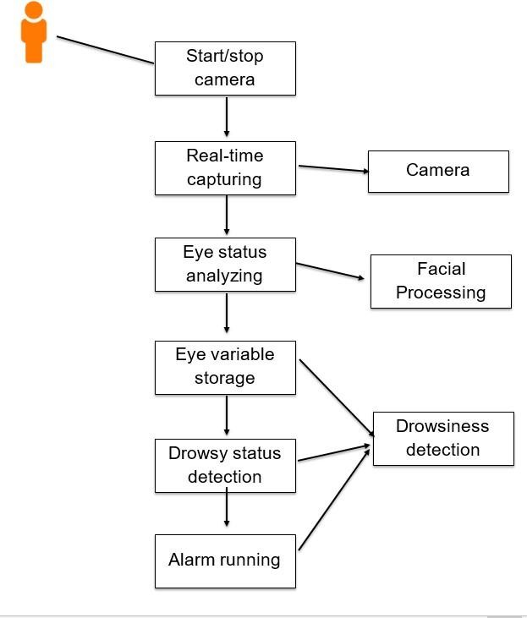

Fig. 4.2. Use Case Diagram

The user can use the application by mounting a camera that captures their face in real-time, the application will constantly monitor the users’ eyes for any signs of drowsiness and if the eyes are closed above a certain threshold then the user is alerted through an alarm or other means as necessary.

## 4.3 Data Flow Diagram

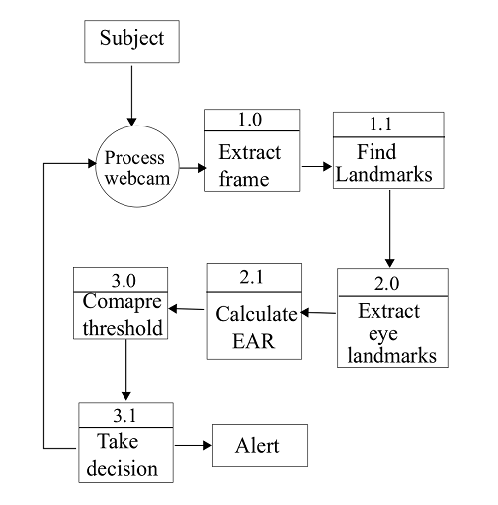

Fig. 4.3. Data Flow Diagram

Data flow diagram is divided into 3 levels. The data from the entity flows through different processes to get results. The model is considered as a process which is divided into 3 different subprocesses input extraction, data processing and Decision taking.

Input extraction contains of opening web cam and capturing frames of the user and finding landmarks on the captured frame. In the second stage known as data processing here the trained model comes into the picture it extracts eye landmarks from the mapped facial marks and calculates the Eye Aspect ratio with above mentioned formula. The final part is Decision taking in the process the calculated EAR ratio is compared to the threshold ration

and decision is taken weather the person is drowsy or not and based on that user will be alerted.

## 4.4 Sequence Diagram

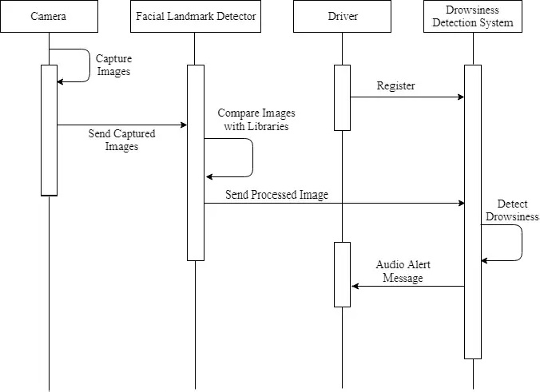

Fig. 4.4. Sequence Diagram

1. Obtain a video feed from a camera that is pointed at the user's face. This can be done using a webcam or a dedicated camera that is mounted in a suitable location.
2. Use the dlib facial landmark detector to identify the coordinates of the user's eyes in each frame of the video feed. This facial landmark detector is a machine learning model that has been trained to identify specific points on the face, including the eyes, nose, and mouth.
3. Calculate the eye aspect ratio for each frame by dividing the distance between the coordinates of the user's eyes by the distance between the horizontal and vertical axes of the user's eyes. This eye aspect ratio is a measure of how open or closed the user's eyes are, and can be used as an indication of drowsiness.
4. Continuously monitor the eye aspect ratio for each frame and compare it to a predetermined threshold value. This threshold value can be determined through experimentation or by using

established guidelines for detecting drowsiness.

1. If the eye aspect ratio falls below the threshold value, it indicates that the user may be drowsy and an alert should be triggered to alert the user to take a break. This alert can be a visual or audible notification, or both, depending on the implementation.
2. If the eye aspect ratio remains above the threshold value, the user is considered to be alert and the process continues with the next frame of the video feed.
3. Repeat this process until the user is no longer in front of the camera or the monitoring is stopped. This allows the system to continuously monitor the user's drowsiness levels and provide timely alerts to prevent accidents or other adverse effects of drowsiness.

# Chapter 5

### HARDWARE AND SOFTWARE REQUIREMENTS

The following are basic hardware and software required to train and test the program.

* 1. **Hardware Requirements**

1. 8 GB RAM
2. Camera (which can process 30fps).
3. 256 GB basic storage.
4. Intel i5 8th gen processor.

## Software Requirements

* + 1. Python
    2. OpenCV
    3. dlib
    4. PyGame

# Chapter 6

# Conclusion

In conclusion, the use of facial landmarks for detecting drowsiness is a promising approach. By training a custom Haar cascade algorithm to detect faces and using a webcam to capture video, we were able to detect faces in real-time and feed them into the dlib library for identifying facial landmarks. By focusing on the landmarks of the eyes, we were able to calculate the Eye aspect ratio and use this metric to determine whether a person was drowsy. This approach has several potential benefits, including the ability to detect drowsiness in real-time, the ability to work with a variety of face shapes and sizes, and the ability to operate in a range of lighting conditions. Overall, this study demonstrates the feasibility and potential effectiveness of using facial landmarks for drowsiness detection.

# REFERENCES

[1] Jianhua Shen, Joseph Barbera, and Colin M Shapiro. Distinguishing sleepiness and fatigue: focus on definition and measurement. Sleep medicine reviews, 10(1):63–76, 2006.

[2] KP Yao, WH Lin, Chiung-Yao Fang, Jung-Ming Wang, Shyang-Lih Chang, and Sei-Wang Chen. Real-time vision-based driver drowsiness/fatigue detection system. In Vehicular Technology Conference (VTC 2010-Spring), 2010 IEEE 71st, pages 1–5. IEEE, 2010.

[3] Mandalapu Sarada Devi and Preeti R Bajaj. Driver fatigue detection based on eye tracking. In Emerging Trends in Engineering and Technology, 2008. ICETET’08. First International Conference on, pages 649–652. IEEE, 2008.

[4] Wenhui Dong and Xiaojuan Wu. Fatigue detection based on the distance of eyelid. In VLSI Design and Video Technology, 2005. Proceedings of 2005 IEEE International Workshop on, pages 365–368. IEEE, 2005.

[5]Liling Li, Mei Xie, and Huazhi Dong. A method of driving fatigue detection based on eye location. In Communication Software and Networks (ICCSN), 2011 IEEE 3rd International Conference on, pages 480–484. IEEE, 2011.

[6] Wen-Bing Horng, Chih-Yuan Chen, Yi Chang, and Chun-Hai Fan. Driver fatigue detection based on eye tracking and dynamk, template matching. In Networking, Sensing and Control, 2004 IEEE International Conference on, volume 1, pages 7–12. IEEE, 2004.

[7] Weiwei Liu, Haixin Sun, and Weijie Shen. Driver fatigue detection through pupil detection and yawing analysis. In Bioinformatics and Biomedical Technology (ICBBT), 2010 International Conference on, pages 404–407. IEEE, 2010.

[8] Zutao Zhang and Jiashu Zhang. A new real-time eye tracking for driver fatigue detection. In ITS Telecommunications Proceedings, 2006 6th International Conference on, pages 8–11. IEEE, 2006.

[9] Ang Liu, Zhichao Li, Lang Wang, and Yong Zhao. A practical driver fatigue detection algorithm based on eye state. In Microelectronics and Electronics (PrimeAsia), 2010 Asia Pacific Conference on Postgraduate Research in, pages 235–238. IEEE, 2010.

[10] Fei Yang, Xiang Yu, Junzhou Huang, Peng Yang, and Dimitris Metaxas. Robust eyelid tracking for fatigue detection. In Image Processing (ICIP), 2012 19th IEEE International Conference on, pages 1829–1832. IEEE, 2012.

[11] Haisong Gu, Qiang Ji, and Zhiwei Zhu. Active facial tracking for fatigue detection. In Applications of Computer Vision, 2002. (WACV 2002). Proceedings. Sixth IEEE Workshop on, pages 137–142. IEEE, 2002.

[12] Bao-Cai Yin, Xiao Fan, and Yan-Feng Sun. Multiscale dynamic features-based driver fatigue detection. International Journal of Pattern Recognition and Artificial Intelligence, 23(03):575–589, 2009.

[13] Chen Yong, Huang Qi, Liu Xia, and Zhang Changhua. All-weather detection method of driver fatigue [j]. Chinese Journal of Scientific Instrument, 3:034, 2009.